Constant di/dt Pulse Method

To implement the Constant di/dt Pulse Method on an automated assembly line for low-nH DC film capacitors, you are essentially building a high-speed, time-domain diagnostic system.
Instead of treating the capacitor like a radio-frequency component (as an LCR meter does), this method treats it like a power semiconductor switch. Here is the deep technical breakdown of how the system works, the physics behind it, and how to build it for production.
1. The Core Physics
The total voltage drop across a capacitor's terminals during a dynamic current event is governed by the standard RLC differential equation:
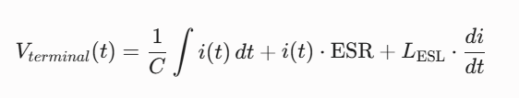
If you force a current that rises linearly and extremely fast (a steep current ramp), look at what happens to each term at the exact microsecond ($t \to 0$) the pulse hits:
- The Capacitance Term (∫ i.dt): Because the pulse width is incredibly short (typically < 2us the capacitor hasn't had time to store any real charge yet. This term drops to effectively zero.
- The ESR Term (i.ESR) At the very beginning of the ramp, the current (i) is still very small, making the ESR voltage drop negligible.
- The ESL Term (L.di/dt): Because the change in current over time (di/dt) is massive and instantaneous, this term completely dominates the voltage equation.
Therefore, at the moment of the step, the equation simplifies strictly to:
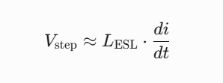
2. The Waveform Behavior (What the Tester Sees)
If you hook a high-speed digitizer or oscilloscope to the capacitor terminals during the pulse, you will see a distinct voltage step:
- The Current Pulse (i): A clean, linear ramp rising from 0A to, say, 100A within 1us (di/dt = 100 A/us )
- The Voltage Response (V): The moment the current starts climbing, the voltage will instantly shoot straight up vertically. This vertical jump is ∆V. After that initial jump, the voltage will begin a slower, linear upward slope (as the capacitor actually starts charging up).
By measuring that immediate vertical jump (∆V) and knowing your pre-set di/dt, the automated system calculates the ESL in real time:
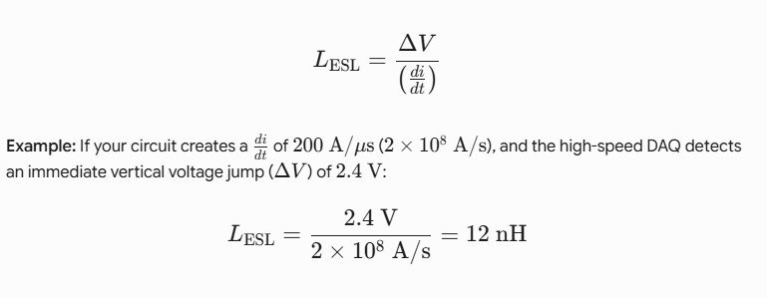
3. Assembly Line Architecture (How to Build It)
To make this automated and repeatable every few seconds on a production conveyor, the tester is divided into three blocks:
[ High-Voltage DC Source ] ---> [ Storage Cap Bank ] ---> [ Fast IGBT/SiC Switch + Inductor ]
|
[ High-Speed DAQ / PLC ] <--- [ Voltage/Current Probes ] <--- [ Pneumatic Busbar Jaws ]
|
[ Capacitor Under Test ]

A. The Pulse Generation Circuit
- Storage Bank: A large internal capacitor bank inside the machine is kept constantly charged to a fixed voltage.
- The Switch: A high-speed, low-internal-inductance SiC (Silicon Carbide) MOSFET or IGBT module. SiC is preferred because its turn-on time is incredibly sharp (nanoseconds).
- The Loop Inductor: A small, high-precision air-core inductor is placed in series with the switch. This inductor acts as a current limiter to linearize the slope, ensuring a perfectly constant and predictable di/dt every single time the switch closes.
B. The Inline Contact Jig (Critical Step)
At low nanohenry levels, you cannot use hand probes or alligator clips.
- The assembly line uses a pneumatic actuator that presses heavy coaxial or coplanar copper bus-plates directly onto the DC-link capacitor's terminals.
- The voltage sensing probes are configured in a Kelvin arrangement (separate from the current-carrying plates) and touch the capacitor terminals at the absolute closest point to the capacitor body to avoid measuring the jig's own inductance.
C. Data Acquisition & Pass/Fail
- A high-speed Data Acquisition (DAQ) digitizer (sampling at >100MS/s) captures the voltage and current waveforms.
- Rather than doing complex curve-fitting, the industrial PC or FPGA looks for the peak of the derivative of the voltage or simply measures the voltage height at a fixed time window (t=100ns) after switch-on.
- If ∆V exceeds a specific threshold (e.g., 3.0V), the PLC triggers a pneumatic reject arm to push the capacitor into the "Fail" bin

4. Why This Exact Method Works For Low-nH Caps
- Signal-to-Noise Ratio: Trying to measure a 10nH capacitor with a tiny 1 V AC signal from an LCR meter gives you microvolts of feedback—easily corrupted by factory noise. Pushing a 100A pulse gives you a massive, clean, multi-volt jump ( ∆V) that factory noise cannot distort.
- Fixture Cancellation: Because the geometry of the pneumatic copper clamping jaws is rigid and identical for every test cycle, the stray inductance of the test rig itself (L_{fixture}) is a fixed constant. You simply subtract it during a golden-master calibration run:
